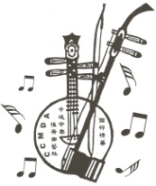 卡城中樂推廣曲藝社
Calgary Chinese Music Development Association
2203 Pegasus Way NE, Calgary, AB T2E 8T2
http://www.calgarychinesemusic.org

主辦
Chinese and Western Music Youth Competition
青少年中西樂器音樂天才比賽
報名表Application Form

Name 姓名
Date of Birth 出生日期
Address 地址
Email 電郵
Telephone 電話
Name and address of your teacher
老師姓名及地址
Category & Instrument組別及樂器
Title and composer of the contest repertoire參賽曲名及作者
Documents Enclosed 附寄証件 | 1. Birth Certificate or ID Card 出生証明或身份証明  2. One Recent Photo 近照一張
I have read all rules as set down in the Competition Prospectus and I undertake to honor these rules and also to accept all decisions of the Jury.
本人已閱讀有關比賽所有規則並願意無條件遵守有關規定及接受評委會一切决定.

______________________________ _________________________________
Candidate’s Signature 参賽者簽名 Parent/Guardian’s Signature
監護人簽名

Date 日期____________________________

